Study Guide – 8th Grade
Module 7

Terms: Electoral College, Precedent, Judiciary Act of 1789, Cabinet, Bank of the United States, National Debt, Bonds, Speculators, Tariffs, Federalist, Democratic-Republican, Loose Construction, Strict Construction, Neutrality Proclamation, Privateers, Pinckney’s Treaty, Whiskey Rebellion, Battle of Fallen Timber, Treaty of Greenville, Federalist Party, Democratic-Republican Party, XYZ Affair, Alien and Sedition Acts, Judicial Review, Louisiana Purchase, Corps of Discovery

People: George Washington, Alexander Hamilton, John Adams, Thomas Jefferson, Aaron Burr, Napoleon, Meriwether Lewis and William Clark, Sacagawea, John Marshall, Henry Knox, Edmond Randolph

- Who were members of Washington’s first Cabinet?
- What were the differing views of the 1st two political parties? How did the parties view the role of the federal government? How did they differ on relationships with European nations? What were their views on interpreting the Constitution?
- Why did Jefferson and Hamilton disagree about tariffs and the National Bank?
- What were the views of Americans towards the French Revolution?
- How did President Washington handle the Whiskey Rebellion? What was the importance of how he handled this rebellion?
- What advice did Pres. Washington give in his Farewell Address?
- How did the Alien and Sedition Acts weaken the Federalist Party?
- What was significant about Jefferson’s victory in the Election of 1800? What led to his victory? How did this lead to a change in the Constitution?
- Why was New Orleans important to “western” farmers?
- What was the importance of the Kentucky and Virginia Resolutions?
- What was the significance of the Supreme Court ruling in Marbury v. Madison?

Essay (20 points) –Remember that an essay is an opinion supported by facts, containing an opening statement, a body and a conclusion.

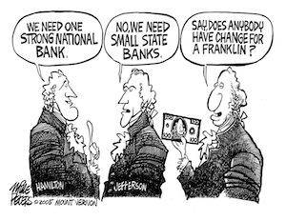
What do the views in the political comic represent? Explain what Hamilton is suggesting and how this reflects the Federalist’s views. Explain what Jefferson’s response means? Which side do you agree with in this debate over federalism? Explain your position. Finally, do these different views still exist after 120 years?

